Get BBO Hands into aaBridge http://RogerPf.com/aaBridge

The aaBridge YouTube channel includes videos that also cover this topic.
See videos numbered 002 and 014 (014 is a MUST view)
There are three ways to get hand(s) from BBO into aaBridge (A, B, C)
The 'single file only ' methods B and C start from Page 5.

Method A. For hand(s) under BBO > Hand records
First open aaBridge. Next, in Chrome (other browsers will also work), go to the BBO site http://www.bridgebase.com and
click the HAND RECORDS link at the top of the opening page.
If you use BBO’s “remember me” option you will need to use the BBO Log off button first before you can see this BBO “front page” HAND RECORDS option.
Or use this direct link http://www.bridgebase.com/myhands once there
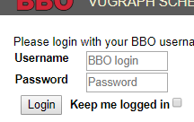
(if needed) login to BBO.

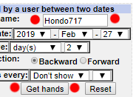
On the next screen enter the name of the user who played the hands and select the dates between which they were played.
Here the user is set to the teacher Hondo717.
Hint – you can select a whole month and not just days(s).
Click the Get hands button (red dots)
Once the list of hands is showing.
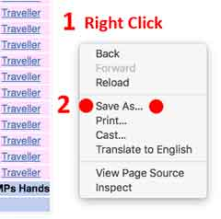
On Windows (and Mac) you can
1. Right Click in the white area.
2. Click Save As... (red dots)

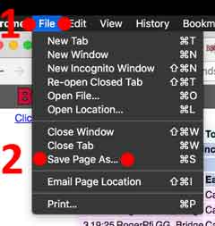
Or on a Mac ONLY
using Chrome's File menu
1. Click File
2. Click Save Page As.. (red dots)

Both methods will open Chrome's Save As dialog.
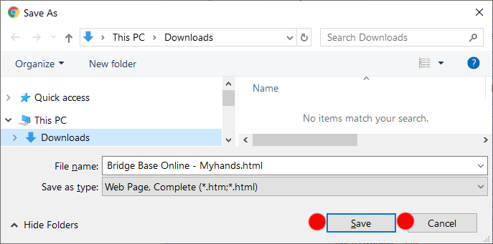
Click Save (red dots)
and if needed say – Yes you want to override the existing file with that name.
That is it …you are done !
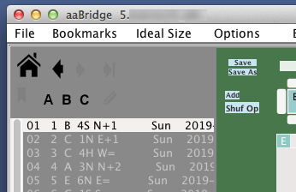
The downloaded hands will now show in aaBridge.
See Example on a Mac →
Please read the notes on the next page.
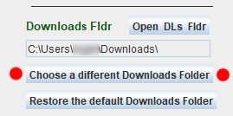
Notes on Method A
You need to save the .html file to your Downloads folder. Your downloads folder location must match that known to aaBridge; for nearly 100% of users it will. If you choose to save the files elsewhere, then tell aaBridge where by raising the lower divider and clicking the button – red dots.
If aaBridge does not notice a new .html file – say aaBridge was not running
when you saved the file, then you can tell aaBridge to process it and display

it by ...
Right Clicking the HOME icon .
OR use the (File) 'Extracts hands ...' menu option below (big red dots).
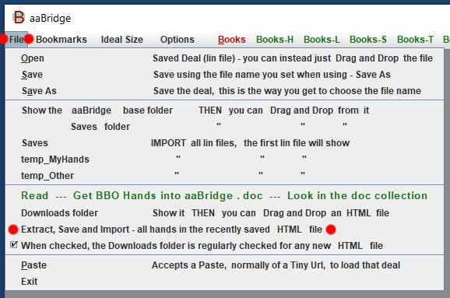
All deals imported from the html file are saved in either temp_MyHands or temp_Other.
Normal deals are saved in temp_MyHands each in its own lin file.
Travelers and Teams matches are saved in temp_Other. Each such set of hands gets its own lin file.
A Quick look at the downloaded hands.
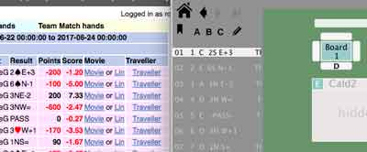
If you compare the list of hands showing in aaBridge it will be the same as those showing in webpage. Compare the two first entries in the image on the right.
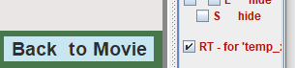
The South Zone
You will notice that the person searched on is always rotated so that their seat is in the South 'zone'. You can stop this from happening (maybe you want to have another seat in the South 'zone'). To turn this feature OFF look near the Back to Movie button and Uncheck the RT checkbox.
Now when you re-load that or any other deal it will not be 'messed with'.
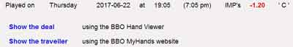
The Traveler
If you click the Back to Movie button. You will see a blue link to the Traveler. You can click it and again download it and view it in aaBridge. As Travelers are saved in temp_Other you can use the arrow buttons next to the Welcome House Icon to move from the main set of files to the Traveler and back.
The Hands
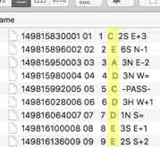
If you use the Show .. temp_MyHands option in the menu shown earlier. You will see a the actual file names of the hands that are now showing in aaBridge.
(The folder is cleared whenever you Extract... another set of hands)
If you look at the filenames you will see a column of letters (shown highlighted in yellow on the right).
The letters are a 'grade' A to E Here 'C' is a middling score and D or E mean you have scored poorly. The idea is that you might like to concentrate your study on the hands with the poor scores. Upper case is for IMPs, lower case indicates MPs.

Method A. Part 2 Getting a Single Deal via Hand Records

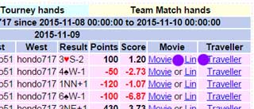
Using the table of deals that you had earlier showing in your browser you can
Double Click any of the Lin links (purple dots).

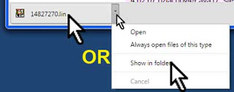
If using Chrome it will be downloaded and show in the bottom left of the browser window.
From there you drag and drop the downloaded lin file onto aaBridge.
OR as shown in the image on the right you can use the drop down menu and drag and drop the lin file from there. OR (on Windows) you can Double Click the file name and it will load in a NEW aaBridge.

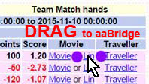
Drag & Drop a lin link on to aaBridge
In addition you can also drag and drop direct from the browser's listing. This works on Chrome and some other browsers. Just drag and drop the lin link (purple dots).

Method B. The hand is still in "My Results"
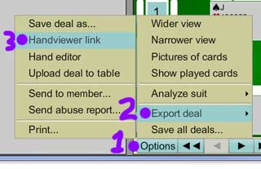
1. Click the Options button
2. Hover over Export deal
3. Click on Handviewer link
(see the numbers / dots in the right image)

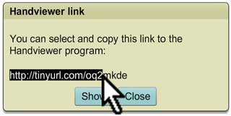
Once the Handviewer link box is showing (takes a couple of seconds).
Select the full line of the URL text (shown in progress here).

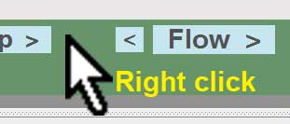
Do a Ctrl-C or use your mouse button (menu) to do a Copy in the normal way.
Right Mouse Click almost anywhere in the aaBridge window. (As shown on the right - a green area is a good place.)
You can think of this Right Click as an aaBridge 'Quick Paste'.
Alternatively
You can use the aaBridge File menu (shown in full earlier) to do a paste (see the red dots above).
On some laptops a light "two finger tap" gesture will also do a "Right Click".
You can also save the link, in a text file. Later you can use a standard Drag & Drop to drop that tiny URL link text into aaBridge.

Method C. You have saved the hand on BBO
You already have the hand on BBO either by uploading it as lin file
OR by using the BBO hand editor to make it
OR by saving it directly to BBO from "My Results"
OR by using Options > Export Deal > Save deal as ...

Now you want to download that deal into aaBridge.

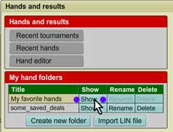
In BBO Click the blue My BBO button
And select the second option
Hands and results (see right image)
Click the blue Show button (purple dots)
of the BBO folder that holds the deal you want to get into aaBridge.

Select the actual deal from the deals in that folder and then
Click the Options button (not shown).

Now follow the instructions given in Method B above.

<end document>

